Press release
16th September 2021

Toni Kroos Academy: the training app that really helps you improve!

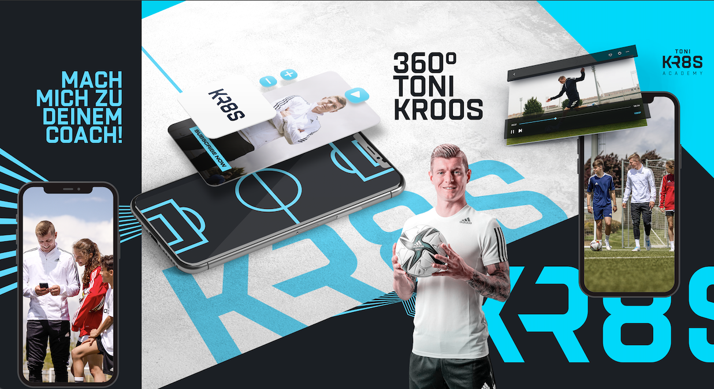

München/ Madrid.
Football legend Toni Kroos has developed his own app. Toni Kroos Academy, now available in all app and play stores worldwide, aims to pass on Toni’s training tips to children and young people and help them improve their footballing skills.

Toni explains: “The idea for the app came to me last year during the first Covid lockdown. While half the world was shut down, I put up TonisHomeChallenge on Instagram. The challenge comprised exercises for viewers to try at home, which my son, Leon, had recorded on his smartphone in our living room or garden. People could copy the exercises at home and send me their recordings. The response was overwhelming. Later on, I brainstormed with a few clever people how to develop the project further. This is how the idea for the Toni Kroos Academy came about. To put it simply, in the material I provide training tips for footballers at all levels, from beginners to junior national players. I select the exercises myself, demonstrate them, explain them, and illustrate them with real match footage from my years as a professional football player. I also offer a glimpse into my everyday life, how I got to where I am now, what obstacles you might encounter on the way up, and what my values are. My goal is to improve the footballing skills of as many kids as possible.”

Toni has been working on the app with a team of developers for a year now. The result is an app that enables the user to get up close to Toni and learn from him thanks to the top-quality, football-specific content.

What makes the app special is the fact that football enthusiasts are not restricted to watching and copying the exercises, they can also video record themselves, upload the clips and receive feedback from Toni himself or coaches selected by him, some of whom work at the Real Madrid Football Academy.

“Young people interact with the digital world from a very early age these days. There is an awful lot of rubbish which kids should steer clear of. That is one of the reasons why I had the idea of ​​creating something useful”, explains Toni. “I would have no qualms about handing my son, who is now seven, a smartphone in order to access this app so he can practise my exercises. It is fun and keeps him busy – and it is ten times better than spending lots of hours slumped on the sofa staring mindlessly at the mobile phone screen."

The app is available in German, English and Spanish. All basic functions are free of charge.

This is the link to the Toni Kroos Academy App:
https://tonikroos.academy/invite

Contact:
Kai Psotta
Tel.: +49 171 7648949
Email: psotta@sports-360.de

Judith Zeeb
Tel.: +49 176 34207681
Email: judith@tonikroos-academy.com

Media Website:
www.tonikroos-academy.com/en/press/

Toni Kroos Academy:
Website: www.tonikroos-academy.com
Instagram: www.instagram.com/toni.kr8s_academy/
TikTok: www.tiktok.com/@toni.kr8s_academy?
YouTube: www.youtube.com/channel/UC0Ltr-TT4h_5lhZJhEqyklQ

